Srikrishna College
(Affiliated to University of Kalyani)
Accredited by NAAC: Grade B+ (3rd cycle)
Bagula, Nadia, West Bengal , Pin-741502

Library facilities for teaching-learning

The College ensures that the teaching–learning process is maintained at an optimal level by providing adequate infrastructural arrangements for Central Library also. This College library have total of 24676 books available at the current academic year 2023-24 The college library provides online public access catalogue service (OPAC), internet browsing facilities, newspaper service, career and cultural magazine service, Economic and Political weekly (EPW) archive service and few related journals service creating the research and innovation environment of the students.

Sr. No | Facilities | Google taged Images
1 | Entrance | 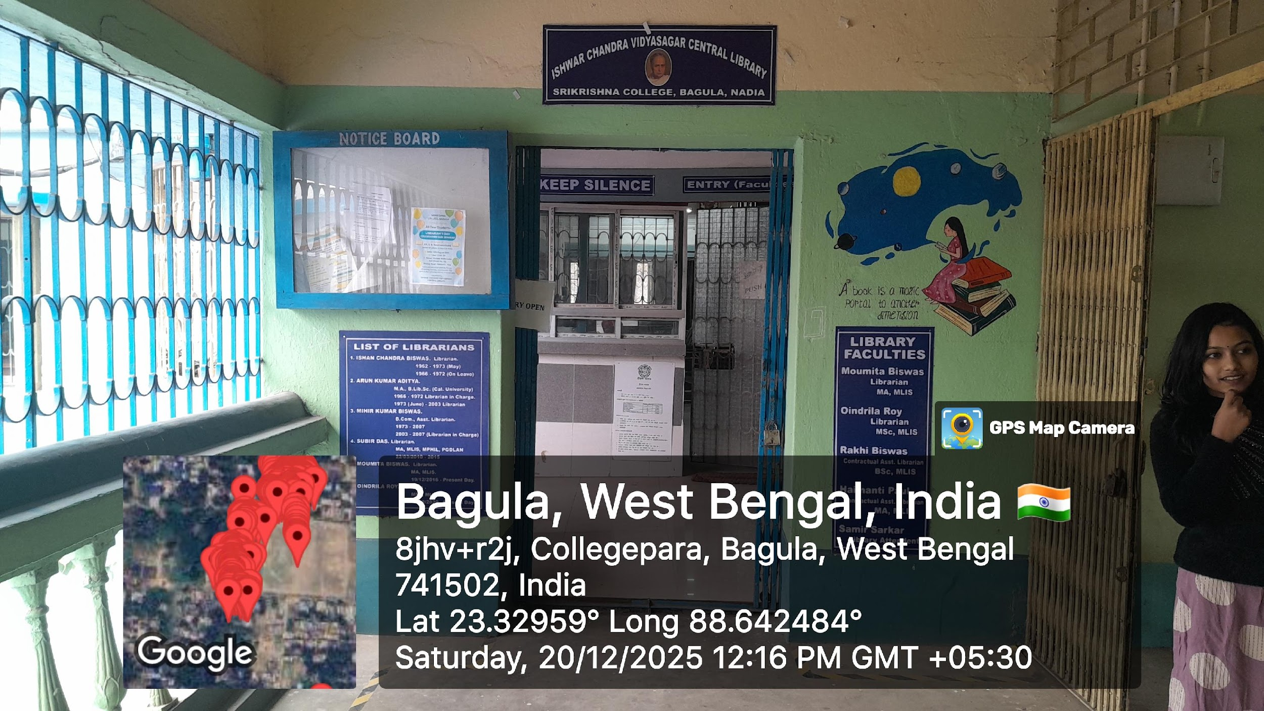
2 | Stack Room | 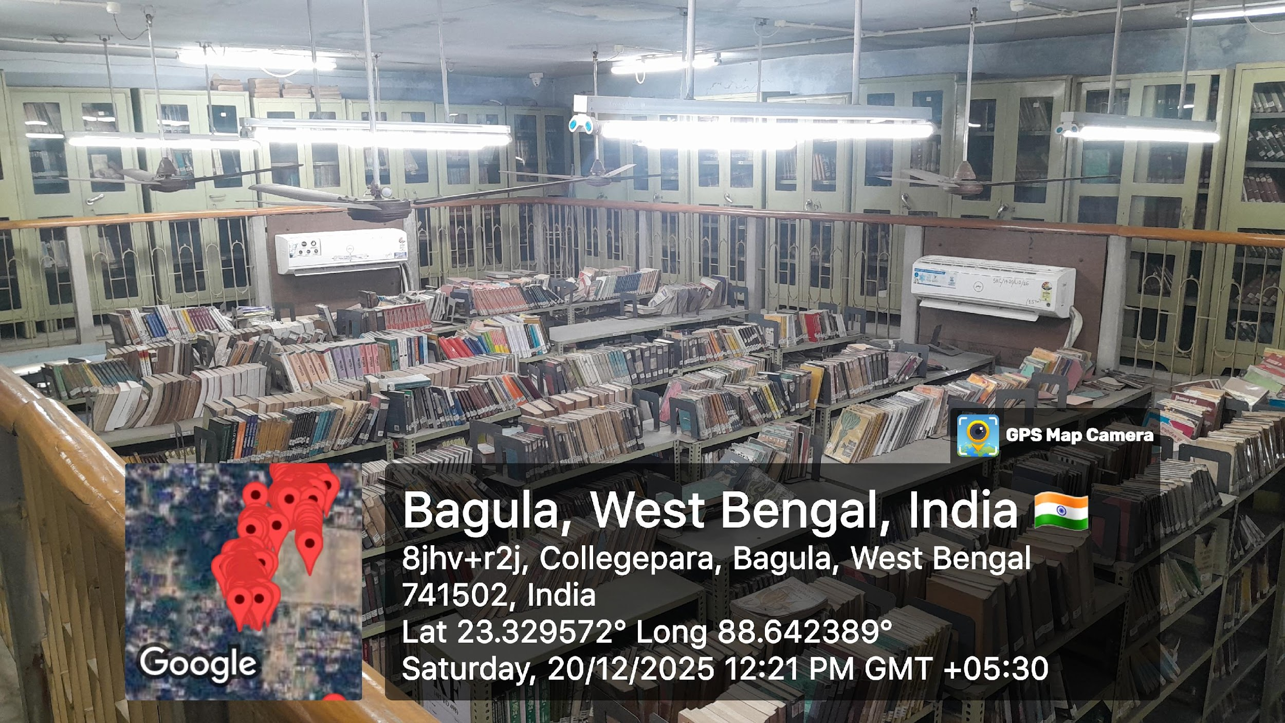
3 | Reading Place | 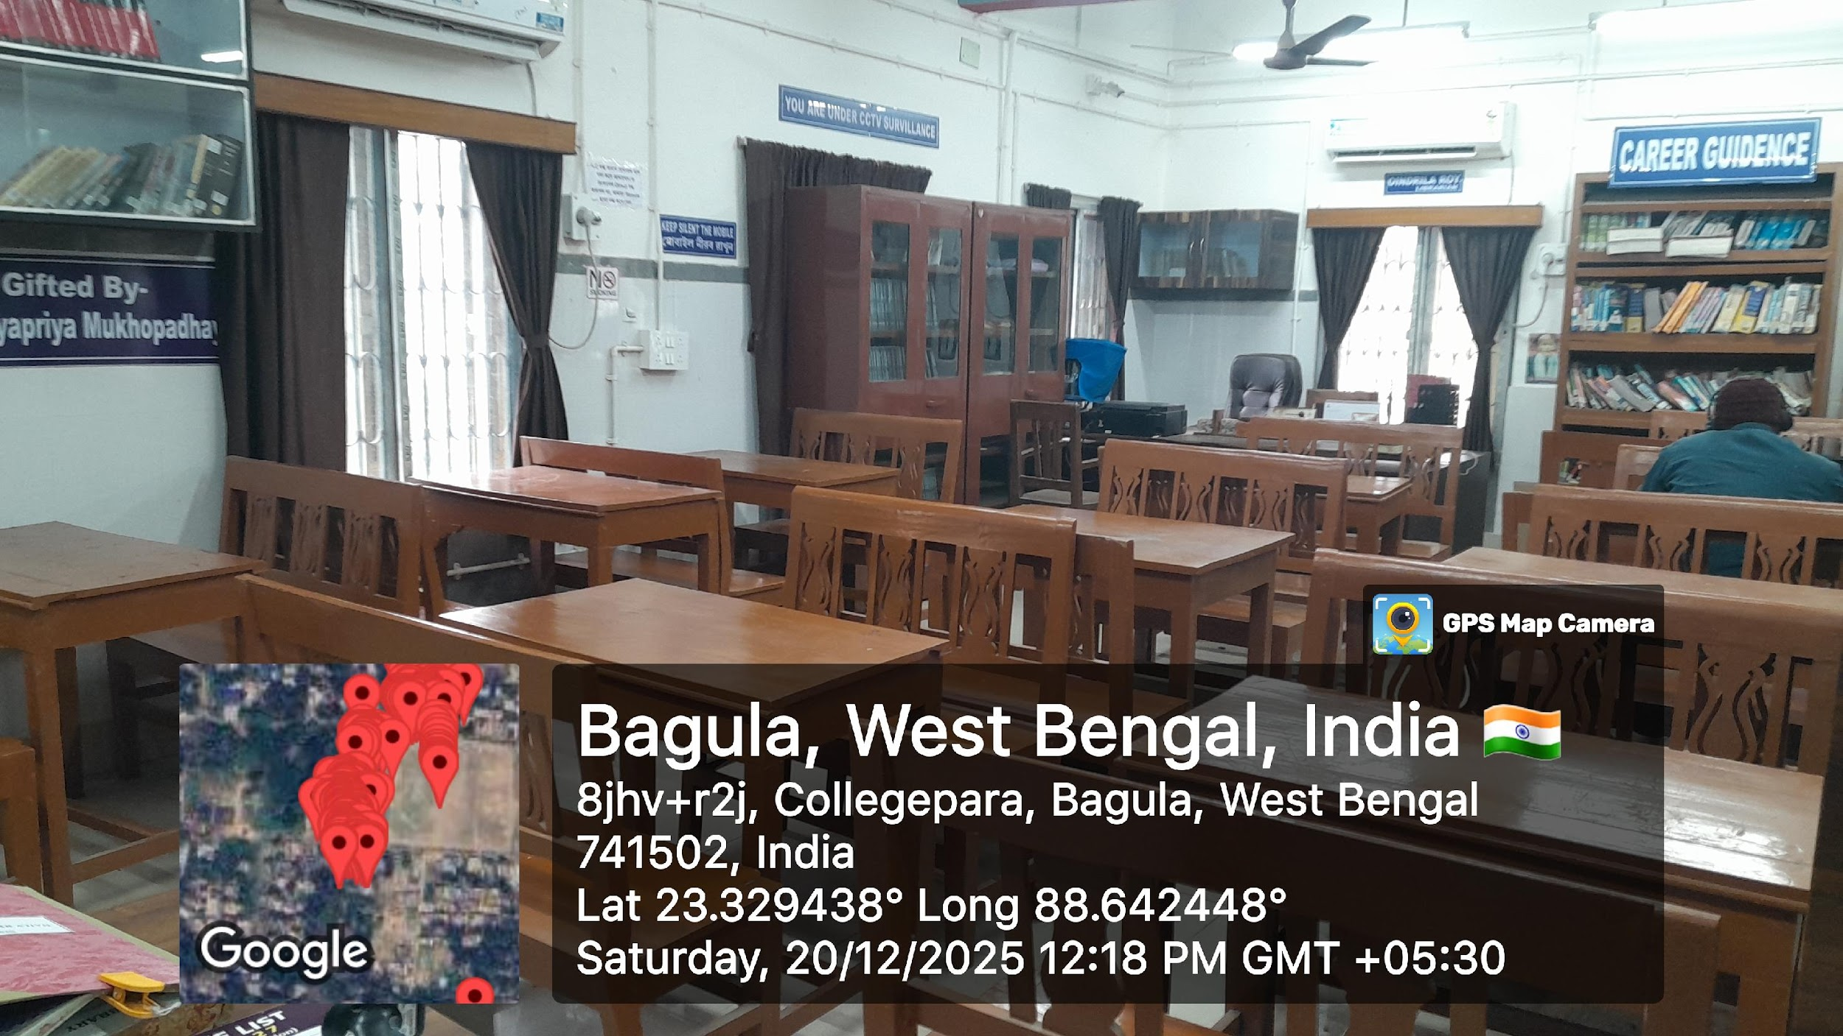
4. | Separate corner for Teachers Research and reading | 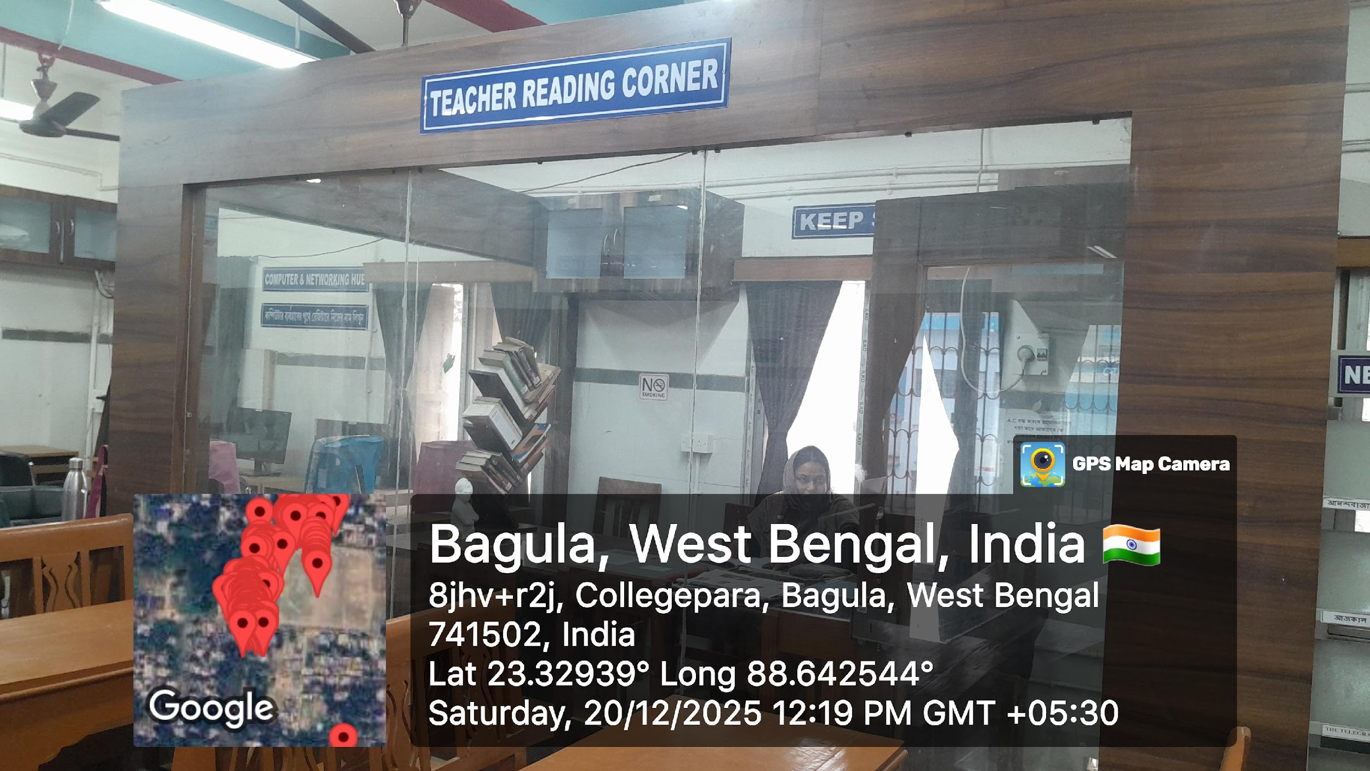
5. | Computer Facility for Students | 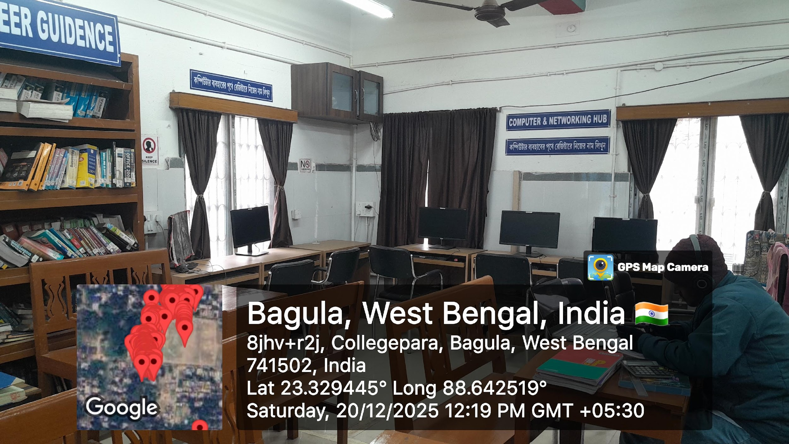
6. | Carrier Guidance stack for students | 